**OBJECT ORIENTED PROGRAMMING**



LAB TASK 3

NAME: Najeebullah khan

ROLL NO: F24_679

SEMESTER: 2nd

SECTION: D

SUBJECT: Object Oriented Programming

SUBMITTED TO: MR Jamal Abdul Ahad

DEPARTMENT OF Computer science

**CREATING AND ACCESSING LIST**

**QUESTION NO: 1**

**Create a list of 5 elements and print the second and last element?**

**Modify the third element and print the update list?**

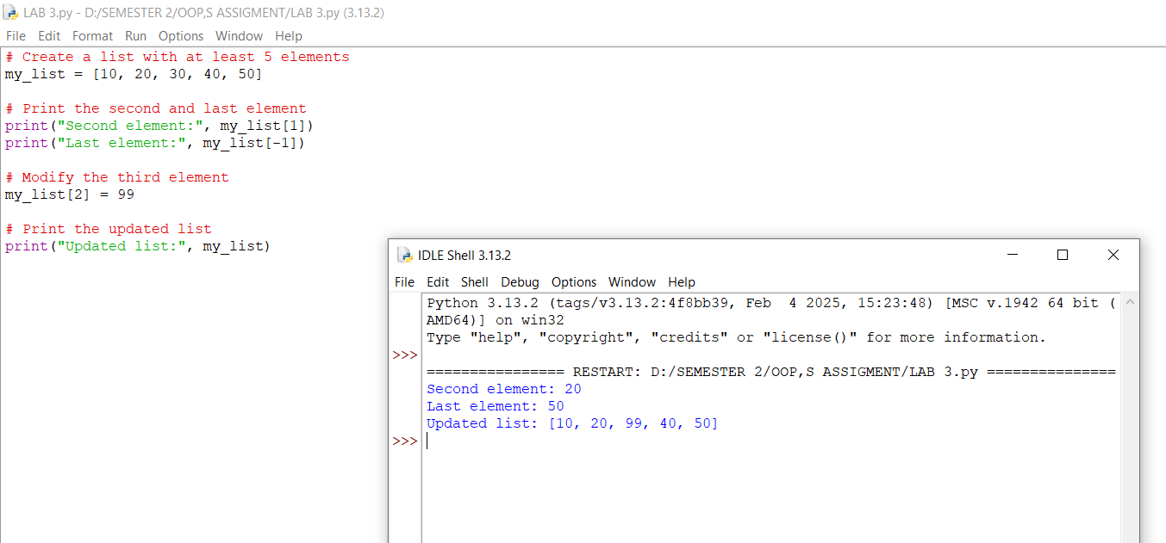

**LIST OPERATIONS**

**QUESTION NO : 2**

**Create two list merge them and check if a specific element exist in the merge list?**

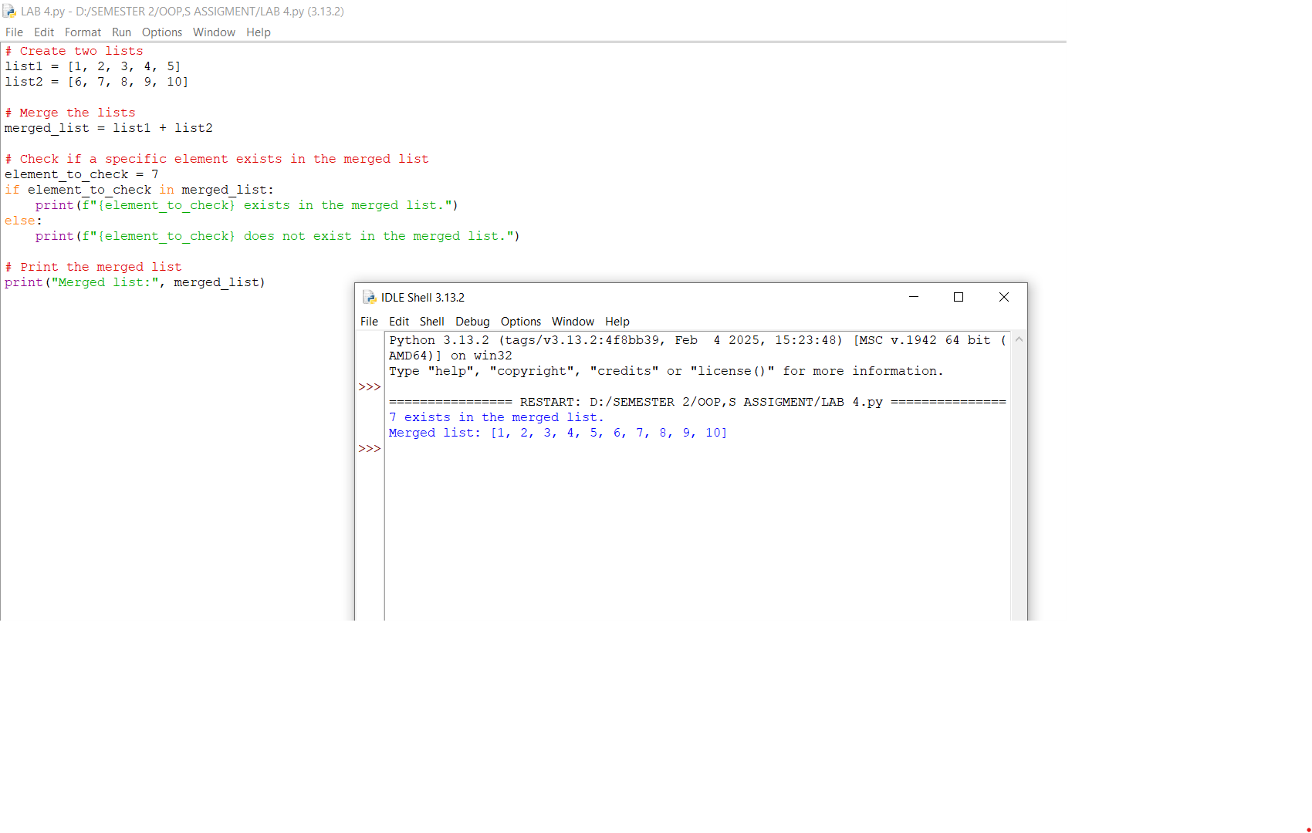**COMMAN LIST METHOD**

**QUESTION NO:3**

**Create a list and perform append, extend, insert, remove, pop, sort, and reverse operations?**

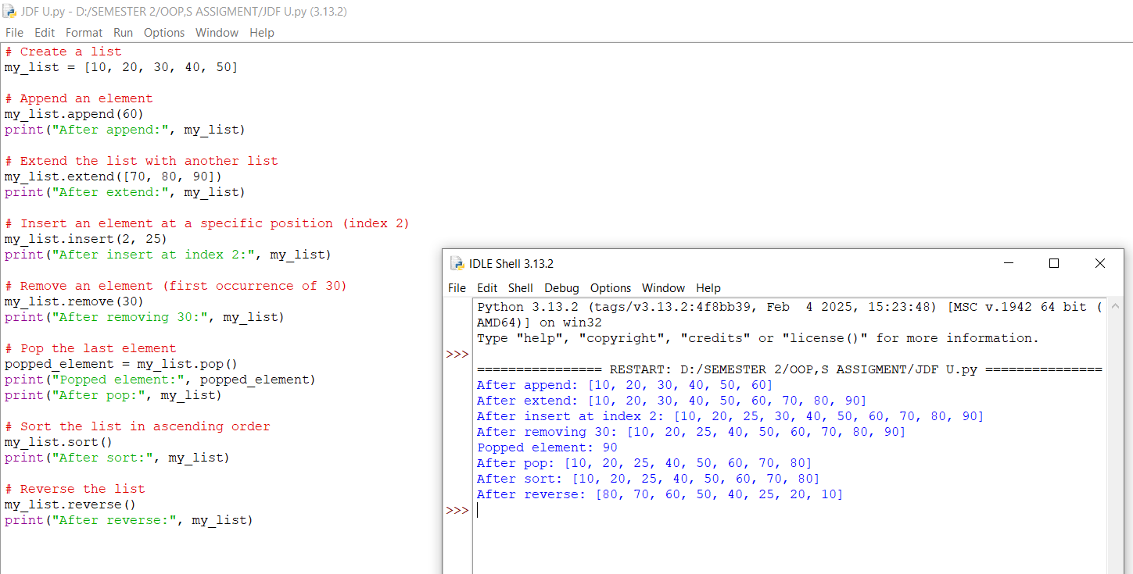

**Iterating over list**

**QUESTION NO : 4**

**Write a program to print each element of a list with in index using enumerate?**

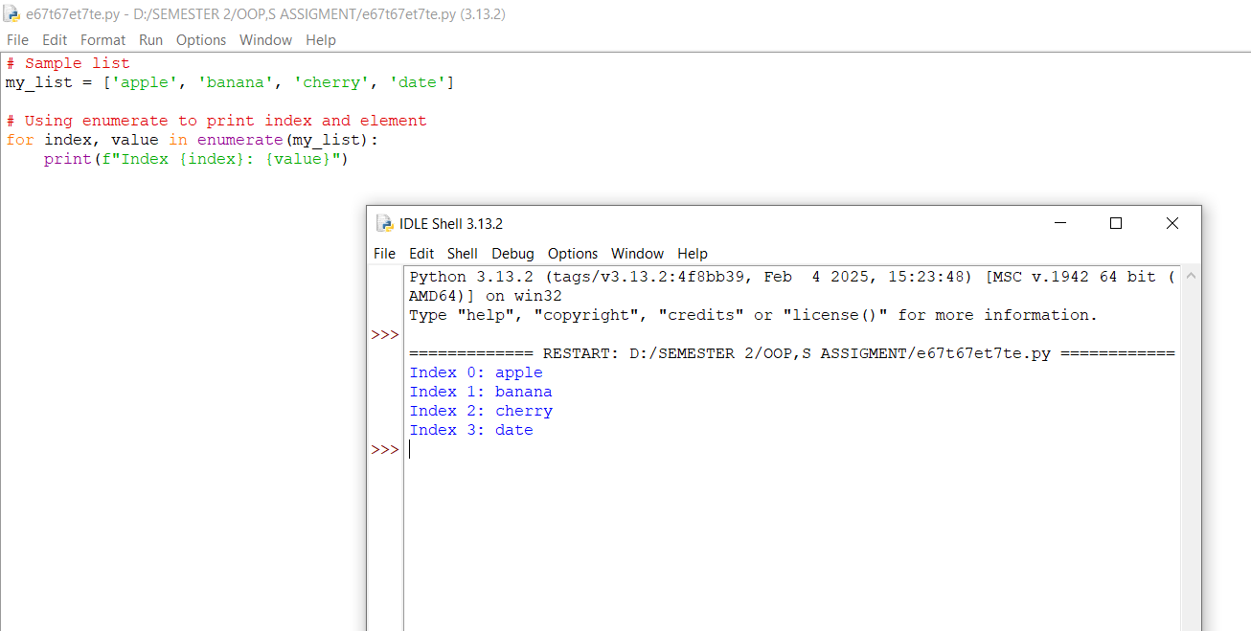

**LIST COMPREHENSIONS**

**QUESTION NO: 5**

**Create a list of numbers from 1 to 20 containing only multiples of 3 using list comprehension?**

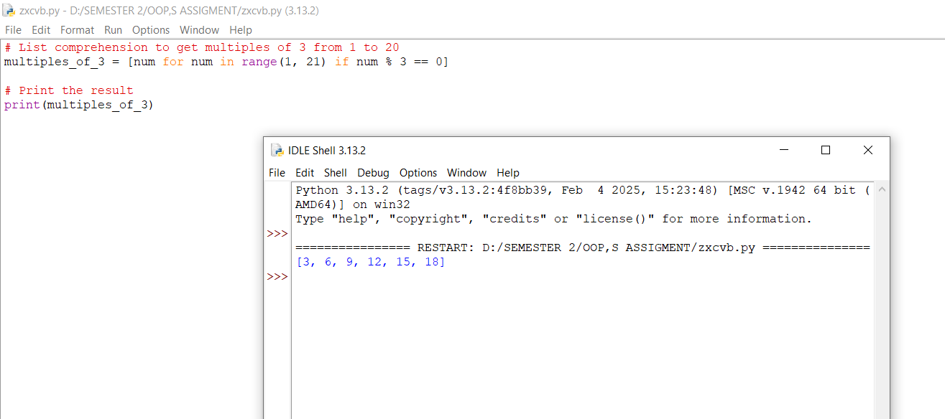

**WORKING WITH NESTED LISTS**

**QUESTION NO: 6**

**Write a program to find the sum of all elements in a nested list?**

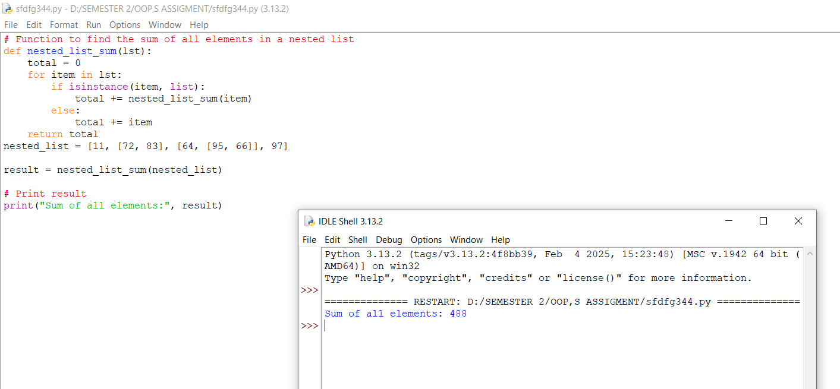

**LIST PERFORMANCE AND OPTIMAZATION**

**QUESTION NO: 7**

**Use deque to implement a queue where elements are added and removed efficiently?**

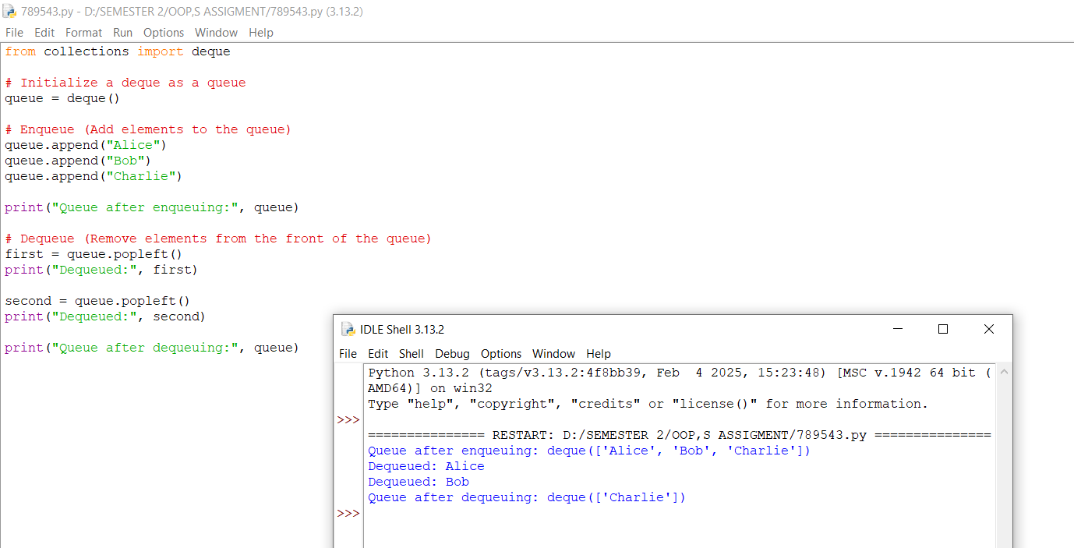

**REAL WORLD APPLICATOION OF LISTS**

**QUESTION NO: 8**

**Build a Python program that manages a list of tasks (adding, removing, displaying) with a menu-driven interface?**

